**Question 1:** A pentagonal prism of base side 20 mm and axis of 50 mm long rests with one of the edges of the base on HP. Its axis is inclined at 30˚ to HP and parallel to VP. It is cut by a horizontal plane passing through the highest corner of the base. Draw the sectional top view.

**Solution:**

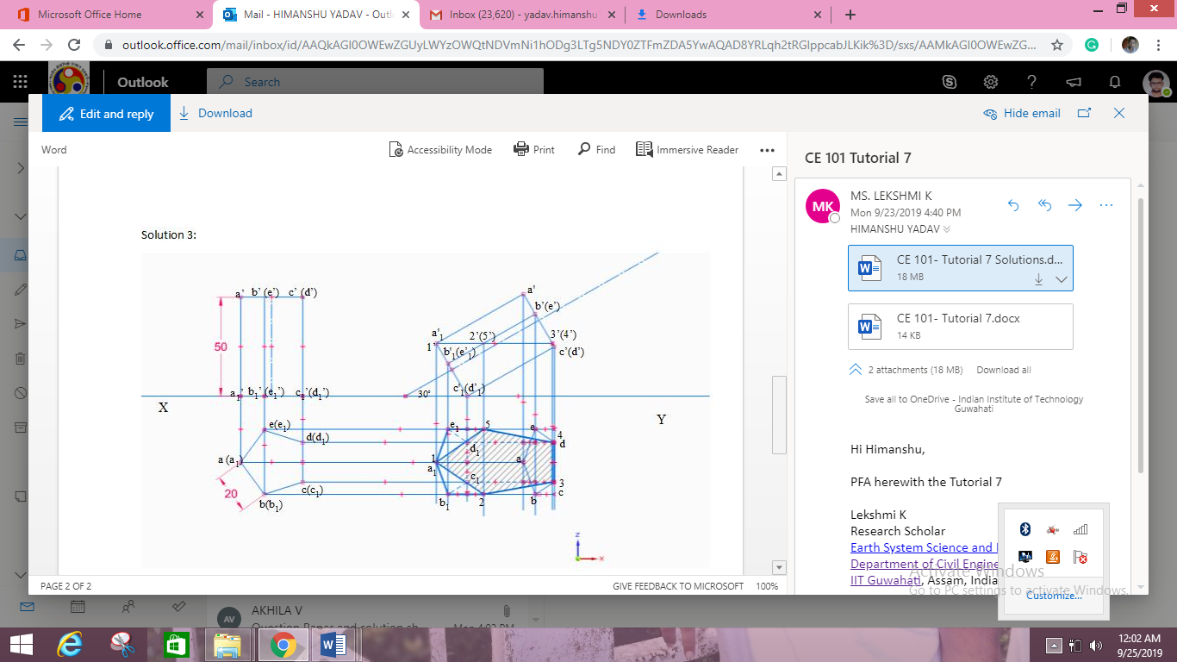

**Question 2:** A cone with 40 mm diameter base and 50 mm length of axis, rests with its base on HP. It is cut by a plane inclined at 75 degrees to HP and perpendicular to VP and passing through the vertex of the cone. Draw the front view, sectional top view and the true shape.

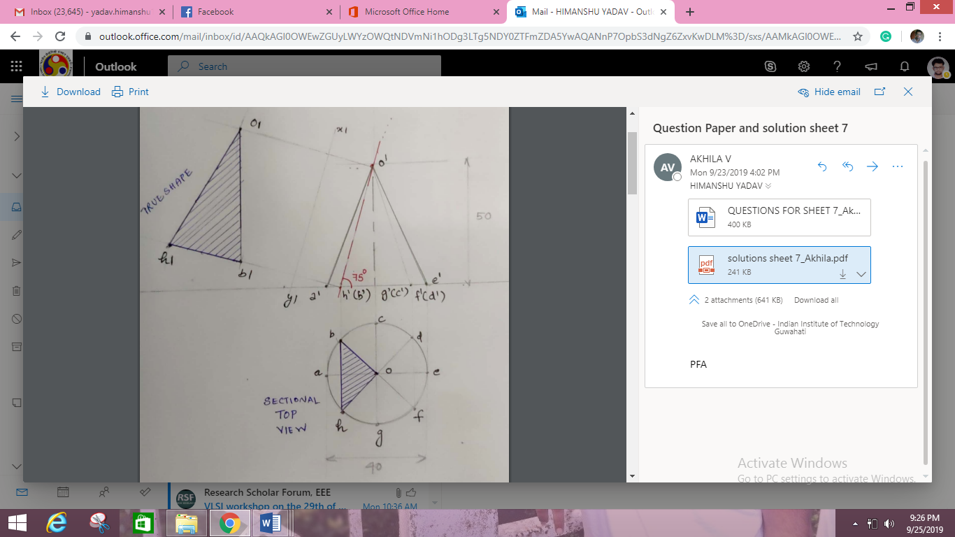

**Question 3:** A hexagonal pyramid side of base 25 mm and 50 mm long axis rests with base on HP and an edge of its base is perpendicular to VP. A section perpendicular to VP, inclined at 30 degrees to HP and passing through a point 20 mm below apex cuts the solid. Draw the sectional side view and sectional top view.

